**WIRELESS CHARGING OF ELECTRIC VEHICLES**

REPORT REPORT

*Submitted in partial fulfilment for the requirements for the award of the degree of*

**Master of Technology**

in

**Power Electronics**

Submitted by

**KATTIRI GIRIDHAR**

**M230979EE**



**DEPARTMENT OF ELECTRICAL ENGINEERING**

**NATIONAL INSTITUTE OF TECHNOLOGY CALICUT**

**FEBRUARY 2024**



**CERTIFICATE**

This is to certify that the report entitled **WIRELESS CHARGING OF ELECTRICAL VEHICLES** is a bonafide record of the Report presented by **Kattiri Giridhar** (Roll no: M230979EE), in partial fulfillment of the requirements for the award of the degree of **Master of Technology** in **Power electronics** from **National Institute of Technology, Calicut**.

**Report Coordinator Head of the Department**

Dr. Jagadanand G Dr. Sindhu T.K

Professor Professor

Dept. of Electrical Engineering Dept. of Electrical Engineering

National Institute of Technology National Institute of Technology

Calicut Calicut

**Acknowledgement**

I have taken considerable efforts in this report. However, it would not have been possible without the kind support and help of many individuals. I would like to extend my sincere thanks to all of them. I would like to thank National Institute of Technology Calicut for providing me with the environment and infrastructure required for completion of this work. I would like to take this opportunity to thank Dr. Sindhu T. K, Head of the Department, Department of Electrical engineering for her support. I wish to express sincere gratitude to my guide, Dr. M Raghuram, Assistant Professor, Department of Electrical Engineering, for the valuable guidance and support.

**Head of the Department**

Dr. Sindhu T.K

Professor

Dept. of Electrical Engineering

National Institute of Technology

Calicut

**ABSTRACT**

Considering a future scenario in which a Driverless Electric Vehicle (EV) needs an automatic charging system without human intervention. In this regard, there is a requirement for a fully automatable, fast, safe, cost-effective, and reliable charging infrastructure that provides a profitable business model and fast adoption in the electrified transportation systems. These qualities can be comprehended through wireless charging systems. Wireless charging of electric vehicles (EVs) represents a promising avenue for enhancing convenience and reducing dependency on traditional charging infrastructure. This report explores various wireless power transfer methods including traditional inductive wireless power transfer, capacitive wireless power transfer and Resonance inductive wireless power transfer etc. Design considerations crucial for efficient implementation are discussed, encompassing coil design considerations, health and safety concerns, and adherence to relevant standards. Furthermore, the report delves into future application concepts of wireless electrical vehicle charging systems, such as wireless vehicle-to-grid integration and in-wheel wireless current systems. These concepts not only offer practical advantages but also pave the way for a more seamless and integrated approach to electric vehicle charging infrastructure. Overall, this report provides valuable insights into the present landscape and future prospects of wireless charging for electric vehicles.

**Contents**

**ABSTRACT**  ii

**LIST OF FIGURES** iv

**LIST OF TABLES**  v

1. **INTRODUCTION** 1
2. **LITERATURE REVIEW**

2.1. Basic working of wireless charging in EVs…………………..……………………….. 3

2.2. Wireless power transfer methods

2.2.1. Microwave power transfer…………………………………….…………….. 4

2.2.2. Optical wireless power transfer……………………………………………… 4

2.2.3. Inductive wireless power transfer…………………………………………… 5

2.2.4. Capacitive wireless power transfer……………………….…………………. 5

2.2.5. Resonance Inductive wireless power transfer……………………………….. 6

1. **DESIGN CONSIDERATIONS OF WPT**

3.1. Compensation networks…………………………………………………….………… 8

3.2. Components of wireless power transfer pads

3.2.1. Coil shapes………………………………………………………….………. 9

3.2.2. Magnetic ferrite shapes…………………………………………….………..12

3.3.3. Protective and supportive structure………………………………………….13

3.3. Health and safety standards…………………………………………………..………..13

1. **APPLICATION OF WEVCS**

4.1. Static wireless electric vehicle charging system (S-WEVCS)………………………… 14

4.2. Dynamic wireless electric vehicle charging system (D-WEVCS)………………........ 15

4.3. Future application concepts of WEVCS

4.3.1. Wireless vehicle to grid (W-V2G)……………………………………….…. 17

4.3.2. In Wheel WCS (IW-WCS)…………………………………………………. 18

1. **CONCLUSION** 20

**List of Figures**

Fig 1. Basic block diagram of static wireless charging system for EVs……..………………….3

Fig 2. Classification of WPT methods…………………………………………………….….… 4

Fig 3. Block Diagram of a Microwave Power Transfer system……………………………..…. 4

Fig 4. Block Diagram of an Optical WPT…………………………………………….…….….. 5

Fig 5. Schematic diagram of inductive WPT……………………………..………………..…... 5

Fig 6. Generic diagram of capacitive Resonant WPT …………..…………………………..…. 6

Fig 7. Generic diagram of magnetic Resonant WPT…………………………………………… 6

Fig 8. Compensation topology (a) Series-Series (b)Series-Parallel (c)Parallel-Series (d) Parallel

-Parallel………………….………………………………………….……….…………… 8

Fig 9. Wireless Transformer (a)exploded view (b)Top view (c)Cross-sectional view…….……10

Fig 10. Coil shapes (a) Circular (b) Square (c) Rectangle (d) Double D (e) Bi-polar (f) Double-D

quadrature(g) Quad-D quadrature…………………………………………………..…..11

Fig 11. Ferrite shapes (a) Circular (b)circular striated (c) square (d) rectangular (e) T- core (f) U

-core (g) E-core (h) Double U (i) striated blocks………………………………………..12

Fig 12. Basic diagram of static wireless electric vehicle charging system……..….......................14

Fig 13. Basic diagram of dynamic wireless electric vehicle charging system…………………...16

Fig 14. Bidirectional power transfer applications (a)wireless V2G (b)plug-in V2G…………….17

Fig 15. Schematic diagram of Static and Dynamic In- Wheel WCS & its internal coil placement

and arrangement………………….…..……………….………………………….…….19

**List of Tables**

Table.1. Overview of methods of wireless power transfer (WPT) for EVs…………………..….7

**Chapter-1**

**INTRODUCTION**

Large scale deployment of Internal Combustion Engine (ICE) based vehicles in transport system lead to the release of harmful fumes into an atmosphere lead to global warming and climate change, which is main concern of global community. Therefore, to lessen dependence on fossil fuel-based energy sources and to reduce its harmful impacts on the atmosphere, there is a need for alternative solutions such as EVs charged on renewable energy sources. Normally, batteries have low energy density, makes them weighty, costly, bulky. In addition, slow in charging and provides shorter lifetime. Now a days lithium-ion batteries are mostly used in EVs. Battery capacity restricts the cruise range. Adding the batteries will increase the cruise range, which further increase the weight and cost of the vehicle. Some of the fast battery charging methods are available which minimizes the full charging time less than 30 min. However, available fast charging systems are costly and complex in control. Still, the charging time of battery more than time that needs to refuel a car based on fossil fuel[1].

Another solution proposed is based on the use of “swapping stations,” where the depleted EV batteries are exchanged with fully charged batteries. For the development of EVs, charging systems are playing the main role. The currently available technology for EV battery charging consists of plug-in charging (conductive charging or wired charging) and Wireless charging (contactless) methods. Plug-in charging system further classified in to Off-Board and On Board chargers based on charging platforms. One of the main concern with conductive charging is high power cables, to plug EV, those are difficult to handle. Hazards can happen due to damaged cables or mishandling. Furthermore, Conductive charging methods are prone to vandalism and theft. An alternative new technology is WPT, introduced by Nikola Tesla in 19th century, with the time this technology developed and became competitive solution for wired charging systems. This technology has capability to replace the plug-in interface by transmitters and receivers, allowing power flow in a contactless manner in the form of electromagnetic or static waves. In WPT systems the receiver transfer power to the batteries or drive system through power electronic converters.

Wireless Charging Systems (WCS) have been suggested for high-power applications, notably electric vehicles (EVs) and plug-in electric vehicles (PEVs) in stationary setups. In contrast to plug-in charging systems, WCS offer advantages in terms of simplicity, reliability, and user-friendliness. However, WCS are currently limited to use when vehicles are parked or stationary, such as in garages, car parks, or at traffic signals. Stationary WCS face challenges like electromagnetic compatibility (EMC) issues, limited power transfer, bulky structures, shorter range, and lower efficiency. To address the range and battery storage volume concerns, research has focused on dynamic operation of WCS for EVs, enabling charging while the vehicle is in motion. This approach reduces the need for expensive battery storage and extends transportation range. Nonetheless, dynamic WCS encounter obstacles such as large air-gaps and coil misalignment. Power transfer efficiency is influenced by coil alignment and air-gap distance between source and receiver, typically ranging from 150 to 300 mm for small passenger vehicles. Alignment of the transmitter coil's optimal driving position is facilitated in dynamic mode. Various compensation methods, such as series and parallel combinations, are utilized on both transmitter and receiver sides to minimize parasitic losses and enhance system efficiency. This report analyzes the fundamental operation of WCS for EVs, including power transfer methods, and explores diverse wireless transformer pad structures aimed at improving power transfer efficiency.

**Chapter-2**

**LITERATURE REVIEW**

**2.1 Basic working of wireless charging for EVs**

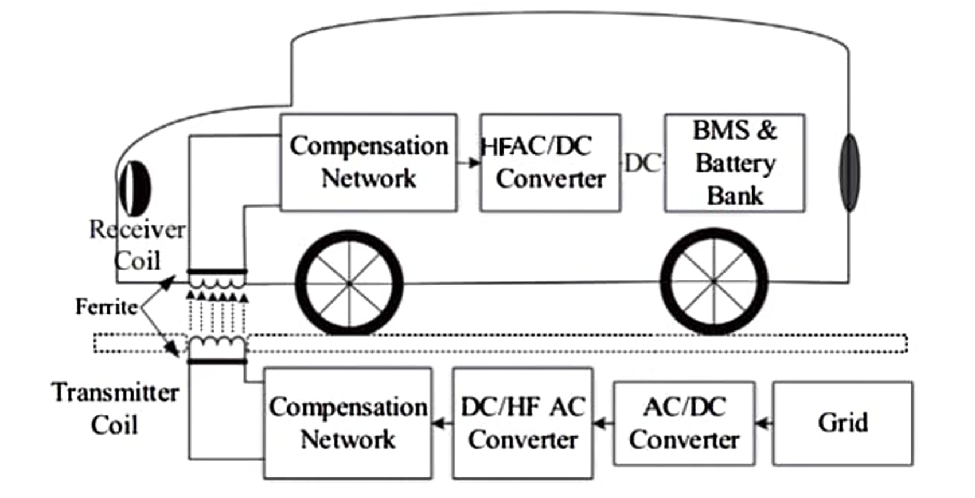The fundamental schematic of the stationary Wireless Charging System (WCS) for Electric Vehicles (Evs) is depicted in Fig. 1. To facilitate the transfer of power from the transmitting coil to the receiving coil, alternating current (AC) from the grid is converted into high-frequency (HF) AC via AC/DC and DC/AC converters. To enhance the overall efficiency of the system, compensation topologies based on series and parallel combinations are integrated on both the transmitting and receiving ends. Positioned beneath the vehicle, the receiving coil converts the oscillating magnetic flux fields into HF AC. Subsequently, the HF AC is transformed into a steady direct current (DC) supply, which is utilized by the onboard batteries. To mitigate any potential health and safety risks and ensure consistent operation, power control mechanisms, communication systems, and a battery management system (BMS) are incorporated. Magnetic planar ferrite plates are employed at both the transmitter and receiver sides to diminish detrimental leakage fluxes and optimize magnetic flux distribution[2].

Fig. 1. Basic block diagram of static wireless charging system for EVs[8].

**2.2 Wireless power transfer methods**

There are several available methods for WPT. It depends upon technology using and transferring frequency level[3]. According to that it categorized into two types. 1) Coupling (Near field), 2) Radiative (Far field). Coupling system further categorized into magnetic field and electric field, Radiative type categorized into two types microwave and laser types, as show in Fig. 2. The WPT methods, and their power transfer range, operating frequency range, sizes of transmitter and receiver, Electromagnetic Interference (EMI) and efficiency are outlined in Table 1.



Fig.2. Classification of WPT methods

**2.2.1** **Microwave Power Transfer (MPT):** MPT is a micro wave based WPT technology in a far-field context. This method can also be operated in Radio-Frequency (RF) range with little adjustments. A high-voltage DC generator feds magnetron (vacuum based oscillator), which generates microwave signal. The generated microwave signal sent out through the antenna, this signal is received by receiving antenna. This receiving antenna also referred to as rectenna. This rectenna consists of both receiver and rectifier which converts the signal in the form DC to charge the battery or load as presented in Fig. 3.

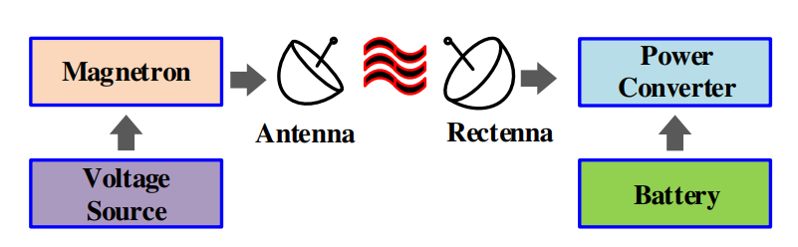

Fig 3. Block Diagram of a Microwave Power Transfer system

**2.2.2 Optical WPT:**  Optical WPT or Laser based power transmission is radiated in the form of electromagnetic waves. However, it is in THz and thus, exists as light. According to this technique, the transmitter consists of laser diode which generates a light beam with particular power and wavelength. Beam director serves to adjust laser diode to control the direction of the light beam. Secondary side consists a Photo-Voltaic (PV) cell and rectifier, PV cell receives light beam converts into a power signal. The power signal converted to DC signal by rectifier. The DC signal fed to power a load or a battery. Fig. 4 presents the block diagram of optical WPT. Ideally, a High Intensity Laser Power Beam (HILPB) system have the ability transfer power to any point Practical limitations like conversion efficiencies limits the performance of the system. In the HILPB system, for effective conversion of laser power to electricity design of PV cell plays major role. For that, the dynamics of the laser power such as wavelength, temperature and the materials of the PV cells 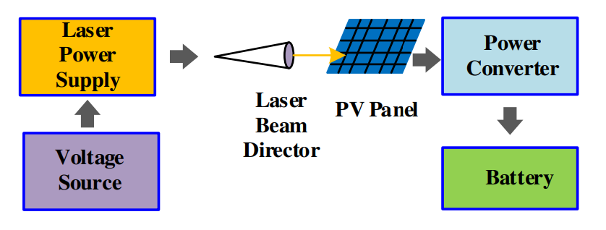should be analyzed carefully. Laser technology for EV still need to be implemented.

Fig 4. Block diagram of an Optical WPT

**2.2.3 Inductive WPT:** Inductive WPT (IWPT) system comprehended with the electromagnetic wave. The working theory of IWPT system based on traditional transformer operation. On the primary side, as per the Ampere's law, an Alternating Current (AC) develops a magnetic field around the conductor (primary side coupler). The developed time varying magnetic field is linked to the magnetic coupler in the secondary side. The Linked field induces a voltage across secondary coil presents Faradays law. Fig. 5 shows the block diagram of IWPT system. This induced voltage converted to DC power signal by rectifier. This power can be used for charging battery. Tuning of secondary coil frequency equal to operating frequency enhance the efficiency of the system. When operating at the range of radio frequency, the limit of air gap extends up to 20 cm at the cost of lower efficiency.



Fig 5. Generic diagram of an inductive WPT

**2.2.4 Capacitive WPT:** It is an Electro static field based systems also referred as Capacitive WPT (CWPT) systems. The CWPT utilizes two parallel metallic plates facing each other acts as a transmitter and receiver to form an equivalent capacitor for transmitting power in the form electro static energy, as presented in Fig. 6. The CWPT system can transfer power through the metallic medium. Compared to IWPT, the CWPT system applicable for both low current and high voltage systems. Additional inductors added to capacitor plates on each side to reduce impedance. This is also called as inductive compensation, it enables soft switching operation and increases power transfer efficiency. Exited voltage in secondary side is altered to Direct Current (DC) by rectifier circuit, to power the battery bank or load with filter circuitry. Furthermore, it is having advantageous such as low weight and less cost than the IWPT systems.

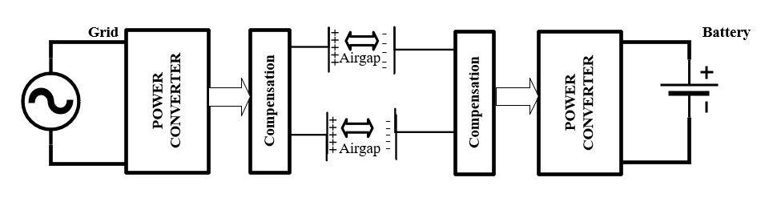

Fig 6. Generic diagram of a capacitive resonance WPT

**2.2.4 Resonance Inductive WPT:** The Resonant Inductive WPT (RIPT) is improved model of traditional IWPT, in terms of power transferring capability, designing and coupler coils. Fig. 7. illustrates base model of the RIPT system for battery charging[4]. Similar to the other WPT system, existed grid voltage is transformed to the High Frequency AC (HFAC) by utilizing power electronics converters. The HFAC signal delivered to the coupler coil. The secondary coupler coil generates voltage by linked magnetic fields. Generated voltage is converted to DC for the powering the battery through power electronics converters and filter circuitry. Compared to IWPT system, Compensation networks (capacitors/inductors or both) added in the series or/and parallel formations to both transmitter and receiving side of the coils to form the resonant condition. That helps improve efficiency by reducing additional losses.



Fig 7. Generic diagram of a resonance inductive WPT

Table 1 presents the summary of available wireless power transfer technologies for battery

operated electric vehicles (BEVs).

|  |  |  |  |  |  |  |  |
| --- | --- | --- | --- | --- | --- | --- | --- |
| **WPT methods** | **Performance** | | | **Price** | **Size/**  **volume** | **Complexity** | **Power level** |
| **efficiency** | **EMI** | **Frequency** |
| Inductive | Medium/High | Medium | 10-50kHz | Medium/High | Medium | Medium | Medium/High |
| Capacitive | Low/  Medium | Medium | 100-600kHz | Low | Low | Medium | Low |
| Resonant inductive | High | Low | 10-150kHz | Medium/High | Medium | Medium | Medium/Low |

Table 1. Overview of methods of wireless power transfer (WPT) for EVs

**Chapter -3**

**DESIGN CONSIDERATIONS OF WPT**

**3.1 Compensation networks**

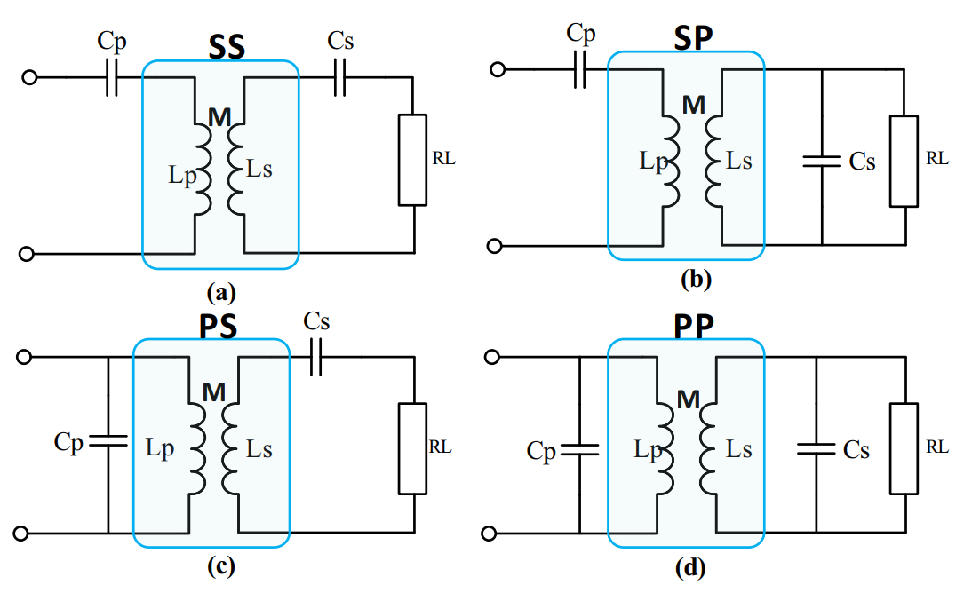As presented in Fig. 7, compensation capacitors are added in series and parallel combinations on both the transmitter and receiver sides in the wireless charging systems for EVs to create RIPT. Four types of compensation network topologies, namely series-series (SS), series–parallel (SP), parallel-series (PS) and parallel-parallel (PP), are shown in Fig. 8.

Fig 8. Compensation topology (a) Series-Series (b) Series-Parallel (c) Parallel-Series

(d) Parallel-Parallel.

The source compensation is required to eliminate phase difference between current and voltage and to minimize the reactive power in the source[5]. The installation of a secondary compensation network maximizes the load power transfer and efficiency. Additionally, the selection of the network topologies relies on the specific application requirements in the WPT. The PS- and PP-compensated WCS are protected so that the source coil does not operate in the absence of the receiver coil. Even though it offers a safe environment, the system is unable to transfer sufficient power in the case of misalignment between the source and the receiver. It also requires additional series inductors to regulate the source current to flow into parallel in the resonant circuit. The value of the capacitor is its reliance on the magnetic coupling and quality factor. The primary compensation capacitor value is not dependent on mutual inductance in SP-based compensated WCS and can offer high power transfer than the graded system. However, it is critically dependent on variation of load. SS- compensated topology is the most suitable for EV applications because it offers two significant advantages. The first advantage is that the value of the capacitor in the source and receiver sides is independent from the load conditions and mutual inductance. As a result, the resonant frequencies of the source and receiver sides are not reliant upon the mutual inductance and loads but depend on self-inductance of the primary and secondary coils. The second advantage is that such systems maintain a unity power factor by drawing active power at the resonant frequency as the reflected impedance from the receiver coil does not add an imaginary part in the transmitter coil. This SS- topology based WCS can offer a better battery charging option because it may offer a constant voltage and current for the battery.

**3.2. Design of wireless power transfer pads**

In the wireless charging systems, the transmitter and receiver pads are made of multiple component layers in order to gain maximum power transfer efficiency and lower electromagnetic interference with cost effectiveness. There are three main components of the wireless power transfer pads: coil, shielding material (ferrite and aluminium plate), and protective and supportive layers. Fig. 9, shows a variety of views of the wireless power transfer pads.

**3.2.1 Coil shapes**

In WCS for EVs, an air-core wireless transformer concept is used to transfer several watts to kilowatts of power from the source to receiver sides[6]. As shown in Fig. 10, a variety of planar coil shapes such as circular, rectangular, and hybrid arrangements have been utilized in the wireless transformer designs to improve performance and to solve misalignment problems between the transmitter and receiver pads. Wireless charging coils are categorized in two main areas: polarized pads (PPs) and non-polarized pads (NPPs). Polarized pads are created from multiple coils and shapes to generate perpendicular (vertical) and parallel (horizontal) components of the flux. In contrast, non-polarized pads are constructed from the single coil shape to produce only perpendicular (vertical) components of the flux. NPPs are the traditional shaped coils, such as circular, square, rectangular and hexagonal. The circular coil is a well-known and widely used structure in wireless transformers because eddy current in this structure is kept to a minimum (there are no sharp edges). By adjusting internal diameter, the magnetic flux distribution can be controlled. For smaller centre diameters, the magnetic field lobe would be a spike shape, which can help to improve the coupling coefficient.

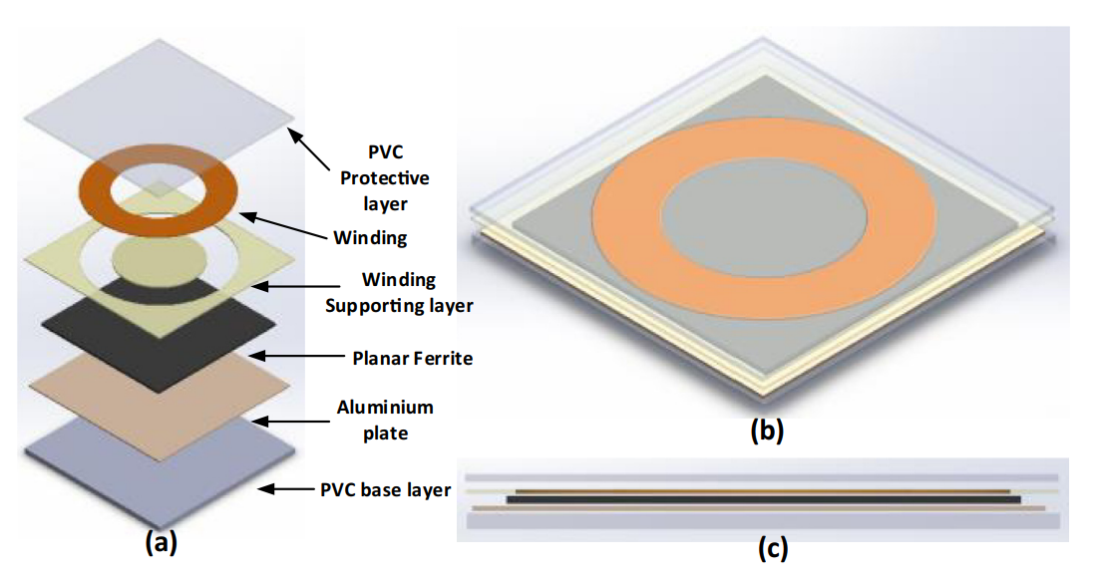

Fig 9. Wireless Transformer (a) exploded view (b) Top view (c)Cross-sectional view [9].

Increasing the centre diameter can expand the magnetic flux distribution areas with lower amplitude compromise, which can assist in misalignment problems. When the offset distance between two windings reaches around ±40%, the receiver power reduces to minimal. Square and rectangular shape coils are suitable when they require arrangement in an array due to perfectly aligned sides. However, they increase inductance because the sharp corner edges generate eddy current and increase impedance and hot spots. This makes it unsuitable for high-power applications. Rectangular shape coils demonstrate greater horizontal misalignment tolerance in comparison to the circular and square coils. However, hexagonal coil shapes present the maximum power transfer efficiency at the central position of the transmitter and receiver coils, but with a significant reduction in the power when it reaches the edge of the coil. Oval shaped coils provide more tolerance with misalignment but these are not suitable for high power applications.

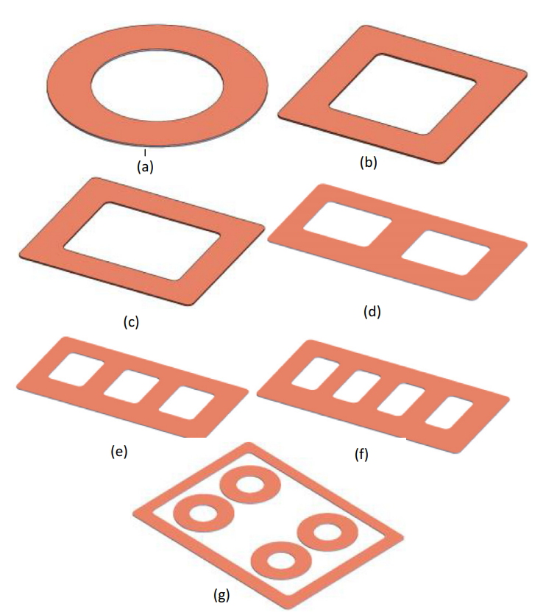

Fig 10. Coil shapes (a) Circular (b) Square (c) Rectangular (d) Double D

(e) Bi-polar (f) Double-D quadrature (g) Quad-D quadrature [9].

Due to poor performance on the horizontal misalignment, PPs are invented by arranging multiple shape coils in a variety of arrangements. Such shapes are not only suitable for single-phase applications, but also for three-phase applications. Solenoidal coil, double D (DD), Double D quadrature (DDQ), bipolar (BP) and Quad D quadrature (QDQ) are examples of the PPs pads or coupler. Solenoidal coils are created by winding coils around the flat ferrite plate, which can produce polarized sharp arching magnetic fluxes on both sides of the coupler. This can be done by magnetically connecting two wound coils in series and electrically in parallel. Such polarized fluxes are higher than the NPP’s fluxes. Double D (DD) polarized pads are created from two square or rectangular coils that generate flux in only one direction (opposite to the ferrite plate) with minimal leakage fluxes at the edge. It offers significant advantages in that it covers both horizontal (X & Y) and vertical directions. In addition, this design can provide an excellent coupling coefficient and quality factors for the unloaded coil.

**3.2.2 Magnetic ferrite shapes**

Another important component of the wireless transformer is magnetic ferrite structure. In the WEVCS, the magnetic flux is generated in medium to high power ranges. This would be high and there is a need to meet safety standards to avoid any health and safety issues. In addition, it affects coupling efficiency between two windings, particularly if there is no shielding to reduce the leakage fluxes. Proper design of magnetic ferrite cores can not only assist to redirect path to magnetic fluxes from primary to secondary, but also improve mutual inductance and self-inductance of the coils. The selection of ferrite core depends on multiple factors including size, shape, permeability, operating frequency and cost. Basic ferrite shapes such as circular, square and rectangular (as demonstrated in E-core and U-core) have been utilized in the source pad as well as on the receiver side to reduce leakage fluxes in the WCS for EVs is shown in fig. 11.

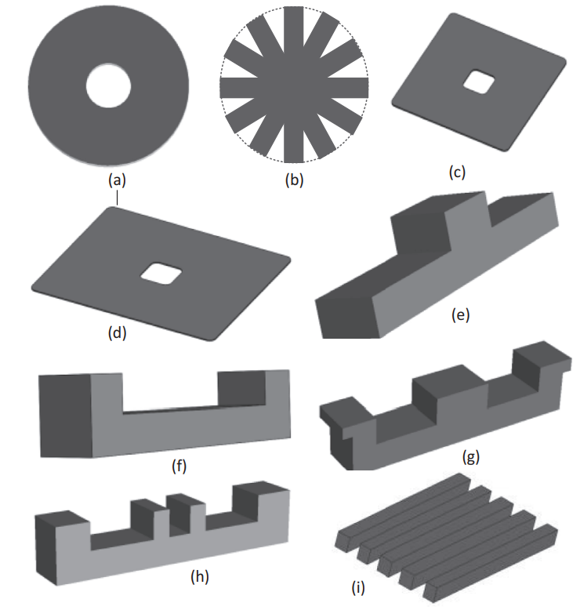

Fig 11. Ferrite shapes (a) Circular (b) circular striated (c) square (d) rectangular(e)T-core (f) U-core (G) E-core (h) Double U (i) striated blocks [9]

Circular hollow and circular arranged ferrite bars have been modified to reduce either weight or cost, or adjusted depending on the application. Even though EE-core, U-core, ETD and pot ferrite shapes offer a higher coupling coefficient, they are not suitable due to their height, because EVs have limited standard ground clearance. Striated ferrite structures have also been utilized to create a variety of shapes and sizes to reduce leakage inductance and enhance cost effectiveness. Higher permeability materials, such as Mn-Zn, are the best option for such application because of affordability and availability.

**3.2.3 Protective and supportive structure**

In WEVCS, the transmitter pad is mounted underneath the concrete structure of the road and is able to handle a car’s weight and additional vibration of the vehicle. In order to improve structure stability, the top and bottom players of the charging pads are manufactured from a PVC plastic sheet. The length and width are dependent on the charging pad size and thickness and vary in size from 5 mm to 20 mm. Sometimes transparent acrylics are also added around the coil for support and to enhance the appearance of the charging pad.

**3.3 Health and safety standards**

In order to create a user-friendly environment for the WEVCS, it is vital to define standards for efficiency, power level, operating frequency, EMI, EMC, and safety and testing for the research and commercialization of the technology[7]. Many international organization’s task forces, such as the Society of Automotive Engineers (SAE), International Electro Technical Commission (IEC), Institute of Electrical and Electronics Engineers (IEEE), and Underwriters Laboratories (UL) have been working with research institutes, governments, universities, and EV automotive industries to enable commercialization. The International Commission on Non- Ionizing Radiation Protection (ICNIRP), Federal Communications Commission (FCC) and American Association of Medical Instrumentation (AAMI) based electromagnetic societies are referred to regarding agreements on EMC levels, EMF limits and compatibility with health monitoring medical implanted devices, such as pacemakers. It is regrettable that aspects of standardization and interoperability are not completely developed because there are some major obstacles to the deployment of this technology.For example, SAE international announces TIR J2954 wireless power transfer standards for PHEVs and EVs with a common operating frequency range between 81.39 and 90 kHz for light duty and passenger’s cars in addition, this standard includes power levels, electromagnetic limits, and minimum efficiency for the experimental and demonstrated purpose of the WEVCS. The SAE J2954 WPT committee carried out a wide variety of validation tests on bench (standardization tests) and vehicle levels (full vehicle tests). In future, additional standards will be announced for the alignment methodology, dynamic WEVCS, and wireless bi-directional power transfer.

**Chapter – 4**

**APPLICATION OF WEVCS**

Depending on their applications, wireless electric vehicle charging systems can be separated into the following two important scenarios to transfer power from the source to the battery bank of the vehicle. Those are,

**4.1 Static wireless electric vehicle charging system (S-WEVCS)**

WEVCS unlocks another door to provide a user-friendly environment for consumers (and to avoid any safety related issues with the plug-in chargers). Static WEVCS can easily replace the plug-in charger with minimal driver participation, and it solves associated safety issues such as trip hazards and electric shock [8]. Fig. 12. shows the basic arrangement of static WEVCS. The primary coil is installed underneath in the road or ground with additional power converters and circuitry.

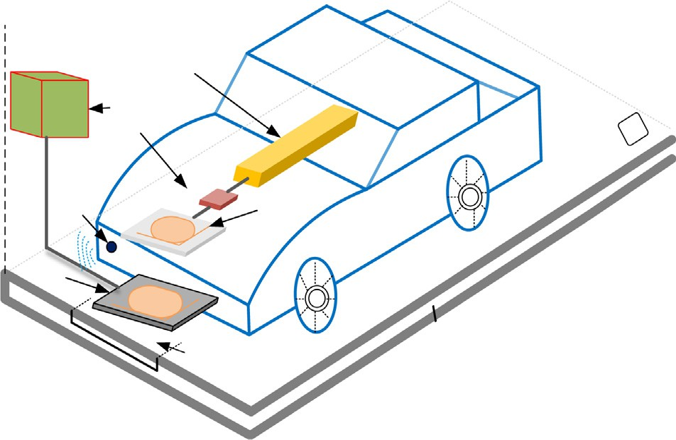

**Energy Storage**

**Power converter**

**Alignment sensor**

**Receiver**

**Transmitter**

**Prefabricated module**

Fig 12. Basic diagram of Static wireless electric vehicle charging system.

(Source: M.H Rashid power electronic Handbook 4th Edition)

The receiver coil, or secondary coil, is normally installed underneath the EVs front, back, or center. The receiving energy is converted from AC to DC using the power converter and is transferred to the battery bank. In order to avoid any safety issues, power control and battery management systems are fitted with a wireless communication network to receive any feedback from the primary side. The charging time depends on the source power level, charging pad sizes, and air-gap distance between the two windings. The average distance between light-weight duty vehicles is approximately 150–300 mm. Static WEVCS can be installed in parking areas, car parks, homes, commercial buildings, shopping centers, and etc. Many prototypes have been developed by universities at research and commercial levels and their prices vary from approximately USD 2700–13,000 from charging levels 3.3–7.2 kW. Their power levels meet with the recently announced international SAE standards (J2954) power class for levels 1 (3.3 kW) and 2 (7.7 kW), including frequency ranges 81.9–90 kHz. Currently, the SAE organization is working on the standards, which are related to allowable misalignment and the installation location of the receiver pads in the car. A number of prototypes have been presented with various mounting locations, such as front, rear, and center of the receiver pads on the underneath of the car.

**4.2 Dynamic wireless electric vehicle charging system (D-WEVCS)**

Plug-in or BEVs are suffering due to two major obstacles - cost and range. In order to increase range, EVs are required to charge either quite frequently or to install a larger battery pack (which results additional problems such cost and weight). In addition, it is not economical to charge a vehicle frequently. The dynamic wireless electric vehicle charging system (D-WEVCS) is a promising technology, which can reduce the problems associated with range and cost of EVs [6]. It is the only solution for future automation EV. It is also known as a ‘‘roadway powered”, ‘‘on-line” or ‘‘in- motion” WEVCS. As shown in Fig. 13. The primary coils are embedded into the road concrete at a certain distance with high voltage, high frequency AC source and compensation circuits to the micro grid and/or renewable energy sources.

Like static-WEVCS, the secondary coil is mounted underneath the vehicles. When the EVs pass over the transmitter, it receives a magnetic field through a receiver coil and converts it to DC to charge the battery bank by utilizing the power converter and BMS. Frequent charging facilities of EVs reduces the overall battery requirement by approximately 20% in comparison to the current EVs. For dynamic-WEVCS, transmitter pads and power supply segments need to be installed on specific locations and pre-defined routes. The power supply segments are mostly divided into centralized and individual power frequency schemes as shown in Fig. 13(a) and (b). In the centralized power supply scheme, a large coil (around 5–10 m) is installed on the road surface, where multiple small charging pads are utilized. In comparison with the segmented scheme, the centralized scheme has higher losses, lower efficiency including high installation, and higher maintenance costs. Overall, the installation of initial infrastructure for this technology would be costly. With the help of a self-driving car in future, it will help to create the perfect alignment between the transmitter and receiver coils which can significantly improve the overall power transfer efficiency. Dynamic-WEVCS can be easily incorporated in many EV 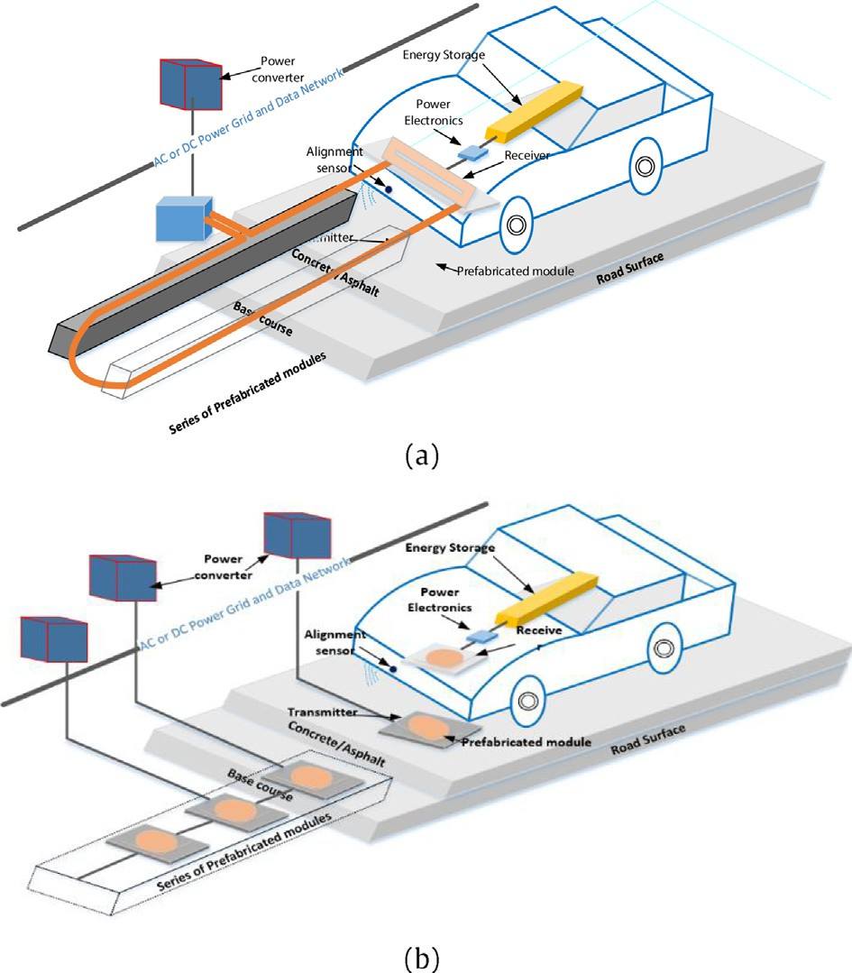transportation applications, such as light duty vehicles, bus, rail, and rapid transport.

Fig 13. (a),(b) Basic diagram of dynamic wireless electric vehicle charging system.

(Source: M.H Rashid power electronic Handbook 4th Edition)

**4.3 Future application concepts of WEVCS**

**4.3.1 Wireless vehicle to grid (W-V2G)**

The express expansion of PEVs has resulted in the need for fast and efficient charging and power transfer methods. With the increasing number of PEVs, the 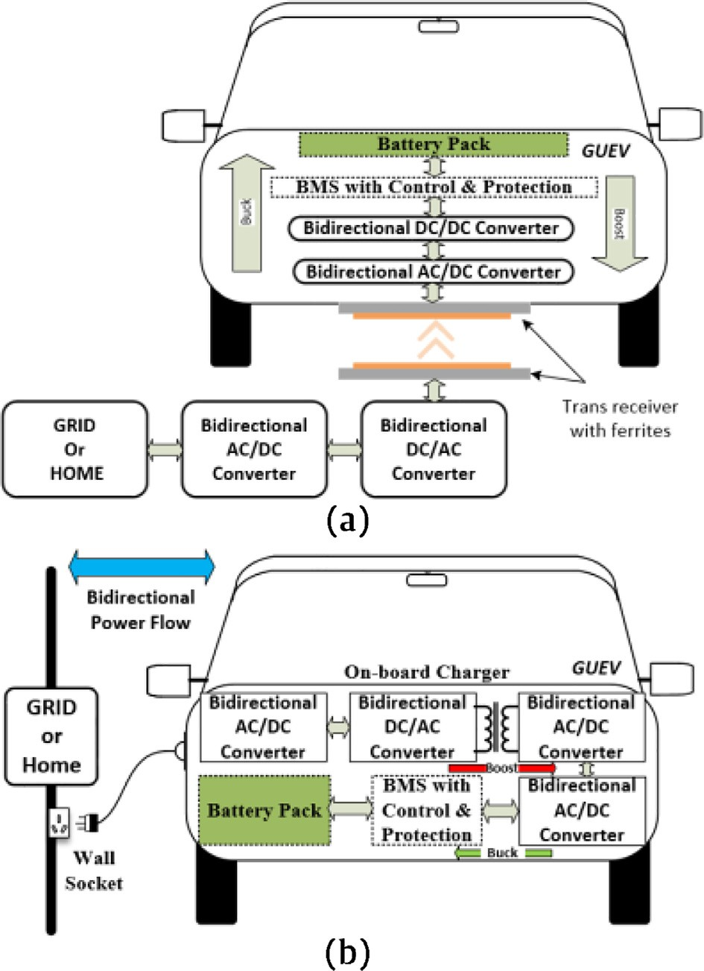

Fig 14. Bidirectional power transfer applications (a) wireless V2G (b) plug-In V2G

(Source: M.H Rashid power electronic Handbook 4th Edition)

power requirements from distribution networks have risen rapidly and created a detrimental impact on it. In order to compensate for the additional power requirements, renewable energy sources have been introduced to the microgrid but they have limited support facilities.

The vehicle-to-grid (V2G) concept can offer a solution alongside advanced scheduling for charging and discharging to the distribution network[9]. Fig. 14(b). shows the bi-directional power transfer application for PEVs with wireless and plug-In modes. In the plug-In V2G, EVs with the on-board bi-directional charger allow the user to connect to the grid or home during peak times. During off-peak times, the vehicle is being charged from an AC wall socket. AC is converted into DC and fed to the isolated DC/DC converter to provide additional safety to the user. Converted DC is transferred to a battery through BMS, control and protection, and a bi-directional DC/DC converter. This converter operates buck (step-down mode) when it charges the battery bank, and boosts when it discharges (in order to increase power level). This is presented in Fig. 14(b). The limitation with this technique is that it requires a physical contact and manual handling to charge or discharge the EVs, which creates additional risks such as electric shock and trip hazards. In order to overcome these problems, a wireless V2G has been introduced, as shown in Fig. 14(a). The primary side of the wireless transformer is embedded on the road or parking surface with bi- directional power converters. The receiver coil is installed underneath the vehicle and the remaining bi-directional power converters are mounted in the vehicle’s body. The design is completely autonomous and provides additional isolation between source and receiver sides, through the wireless transformer. The design enables surplus energy to be transferred to the PEVs to reduce stress or receive energy to rectify peak demand energy in static or dynamic modes.

**4.3.2 In Wheel WCS(IW-WCS)**

Stationary WEVCS already present some challenges, such as EMC issues, limited power transfer, bulky structures and higher efficiency. Furthermore, the power transfer efficiency depends on the coil alignment and air-gap distance between the source and receiver. The average air-gap distance varies from 150 to 300 mm for small passenger vehicles while it may increase for larger vehicles. The alignment can be solved by utilizing sensing technology or parking assistance, which can guide the driver to find the center of the coil. Dynamic-WEVCS technology has to overcome two main hurdles, large air-gap and coil misalignment, before it is more widely accepted. Due to the large number of source coils, the misalignment problem can be solved to some extent. In order to rectify air-gap problems in the WEVCS, in-wheel WCS (IW-WCS) has been developed for stationary and dynamic applications. It is also less dependent on any standardization receiving coil shape and locations. Static and dynamic IW-WCS are future technologies that can be used to charge EVs or PHEVs while they are stationary or in motion. Due to lower air-gaps and higher coupling efficiencies between the transmitter and receiver, IW-WCS has significant advantages over the exiting dynamic-WCS. Like other WEVCS, the multiple primary or source coils are normally installed under the road surface. The basic schematic diagram of IW-WCS for stationary and dynamic applications is presented in Fig. 15. The main grid source is converted to a high frequency (HF) AC source, which is connected to primary windings through a compensation circuit. Unlike other WEVCS, the secondary coils are installed into the tyre structure in the IW-WCS. The air-gap between the source and receiver coils in an IW-WCS is smaller in comparison to the current static or dynamic-WEVCS. The three main structural components in an IW-WCS are the wireless transformer coils, power source, and internal structure of the tyre, which need to be designed carefully in order to achieve an efficient static and dynamic- IW-WCS. Detailed internal placement of the receiver coils is demonstrated in Fig. 15.

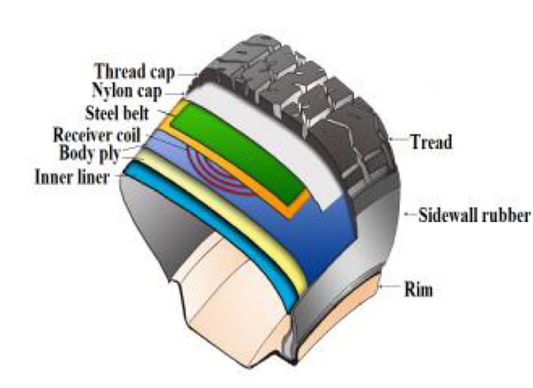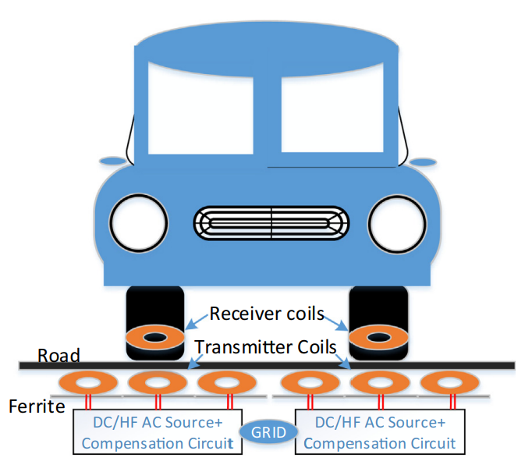

Fig 15. Schematic diagram of Static and Dynamic In-Wheel WCS & its internal coil placement and coil arrangement.

(Source: M.H Rashid power electronic Handbook 4th Edition)

Multiple receiver coils are placed in a parallel combination inside the tyre. The advantages of such an arrangement are that only the particular receiver coil that is in contact with the transmitter is activated. In some cases, when horizontal misalignment occurs, multiple receiver coils can be activated. These transfer power to the battery bank or load. Each receiver coil contains a resonant capacitor, rectifier, and filtering circuitry. The recommended location for the receiver coils array is between the steel belt and body ply.

**Chapter-5**

**CONCLUSION**

This report presents a basic overview of the WEVCS for stationary and dynamic applications with current researched technology. In addition, a variety of core and ferrite shapes have been demonstrated, which have been utilized in current wireless charging pad design. Health and safety issues have been raised and current developments in international standards are discussed. Moreover, the report has delved into futuristic application concepts such as wireless vehicle-to-grid integration and in-wheel wireless current systems. These innovations not only promise practical advantages but also pave the way for a more seamless and integrated approach to electric vehicle charging infrastructure. In summary, this report has provided valuable insights into both the current landscape and future prospects of wireless charging for electric vehicles. With ongoing advancements and developments in this field, the vision of widespread adoption of wireless charging systems for EVs appears increasingly feasible, promising a more sustainable and efficient transportation ecosystem.

**Bibliography**

1. P. Lopes, P. Costa and S. Pinto, "Wireless Power Transfer System For Electric Vehicle Charging," 2021 International Young Engineers Forum (YEF-ECE), Caparica / Lisboa, Portugal, 2021, pp. 132-137
2. P. Eekshita, N. S. V. Narayana and R. Jayaraman, "Wireless Power Transmission System," 2021 International Conference on Computer Communication and Informatics (ICCCI), Coimbatore, India, 2021, pp. 1-4
3. A. Mahesh, B. Chokkalingam and L. Mihet-Popa, "Inductive Wireless Power Transfer Charging for Electric Vehicles–A Review," in IEEE Access, vol. 9, pp. 137667-137713, 2021, doi: 10.1109/ACCESS.2021.3116678.
4. F. N. Ibrahim, N. A. M. Jamail and N. A. Othman, "Development of wireless electricity transmission through resonant coupling," 4th IET Clean Energy and Technology Conference (CEAT 2016), Kuala Lumpur, Malaysia, 2016, pp. 1-5, doi: 10.1049/cp.2016.1290.
5. C. Qiu, K. T. Chau, C. Liu and C. C. Chan, "Overview of wireless power transfer for electric vehicle charging," 2013 World Electric Vehicle Symposium and Exhibition (EVS27), Barcelona, Spain, 2013, pp. 1-9, doi: 10.1109/EVS.2013.6914731.
6. A. A. S. Mohamed, S. An and O. Mohammed, "Coil Design Optimization of Power Pad in IPT System for Electric Vehicle Applications," in IEEE Transactions on Magnetics, vol. 54, no. 4, pp. 1-5, April 2018, Art no. 9300405, doi: 10.1109/TMAG.2017.2784381.
7. S. A. Sabki and N. M. L. Tan, "Wireless power transfer for electric vehicle," 2014 IEEE 8th International Power Engineering and Optimization Conference (PEOCO2014), Langkawi, Malaysia, 2014, pp. 41-46, doi: 10.1109/PEOCO.2014.6814396.
8. Chirag Panchal, Sascha Stegen, Junwei Lu,Review of static and dynamic wireless electric vehicle charging system, Engineering Science and Technology, an International Journal, Volume 21, Issue 5,2018,Pages 922-937,ISSN 2215-0986,
9. D. Patil, M. K. McDonough, J. M. Miller, B. Fahimi and P. T. Balsara, "Wireless Power Transfer for Vehicular Applications: Overview and Challenges," in IEEE Transactions on Transportation Electrification, vol. 4, no. 1, pp. 3-37, March 2018, doi: 10.1109/TTE.2017.2780627.